HUNGER AND THIRST FOR GOD'S WORD IN KENYA
Mission trip to Kenya from May 13 to June 4, 2022
“I have set before you an open door, which no man can shut.” (Rev. 3:8)
“You prophesied about my brother in the 1990s,” Pastor Chelule said, “that the Lord would give him the ministry of pastor. He has now founded fifteen other churches in addition to his own congregation.”
Those are encouraging words to hear after more than two years of not being in Kenya. God is good! From our "home base" Nkong Hills, where we stayed with our host Bishop William Tuimising, we visited several churches to serve them with God's word.

Deliverance Church Embul bul. In the daily lunchtime meetings and the midweek service on Wednesday evenings people came, longing to hear God's word. Some closed their shop for this, but testified that they sold much more after the service. The Sunday with two services was a real revival. Churches in Kenya have also suffered from the corona pandemic and were closed for a year. As well as the schools. Many came forward for repentance, healing, and the baptism in the Holy Spirit.

To the “Kamiti” prison in Nairobi. Bishop Tuimising's eldest son has a prison ministry and gave us the opportunity to bring the Gospel here. The group consisted of approximately 150 boys between the ages of 18 and 21. After the call who wanted to give his heart to Jesus 25 of them raised their hands and received Jesus as their Savior the Lord. Praise the Lord for that.
We gave them toothpaste and underwear as gifts. Because they really don't have anything there. Later also 2 footballs, a volleyball and toothbrushes.
Their enthusiasm knew no bounds.

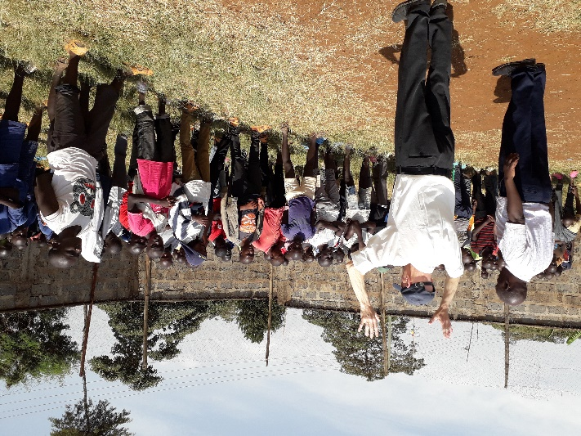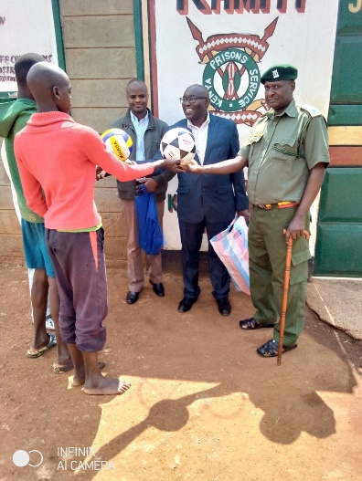
Deliverance Church Kimende by Pastor Faith. This single woman had also received a prophecy from Eltjo in the 1990s that she would get the ministry of pastor. She has a large church, which is now too small for this rapidly growing congregation. She wanted us to prophesy about her church members. God is a speaking God and His word will not return to Him void. (Isaiah 55:11) In the Sunday service people came forward for repentance, deliverance and healing.
A young man was cured of diabetes and a woman delivered from evil spirits. Hallelujah! We had to come back another Sunday as we couldn't serve everyone.

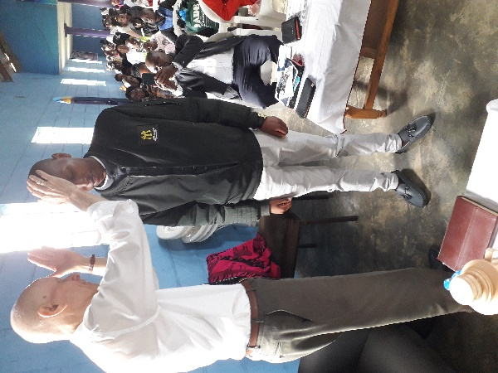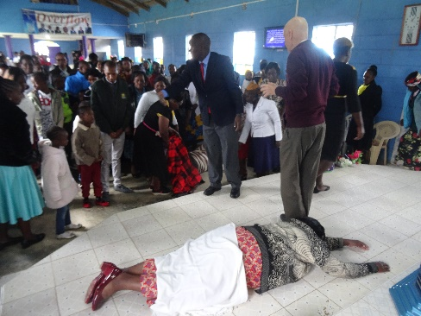

Deliverance Church Eastleigh in Nairobi. We also held lunchtime meetings there and a midweek service, where people were powerfully touched by the Lord.
The last week we were inland for three more days. To Bomet, where we had preached many times in the past. The pastors were not happy that we did not come to them, so Bishop Tuimising organized a lunch meeting where we could still pray and prophesy for these fourteen pastors. Great joy not only because of the reunion, but all the more of the powerful words spoken by the Holy Spirit. His word always does what pleases Him and what He sends it to.
“Pursue love and strive for the gifts of the Spirit, but especially for prophesying”. (2 Corinthians 14:1)

All praise and thanks to the Lord Jesus, who gave His life on the cross of Calvary to save sinners and shed His blood for the forgiveness of sins. And by His resurrection from the dead giving Eternal Life to everyone who believes.

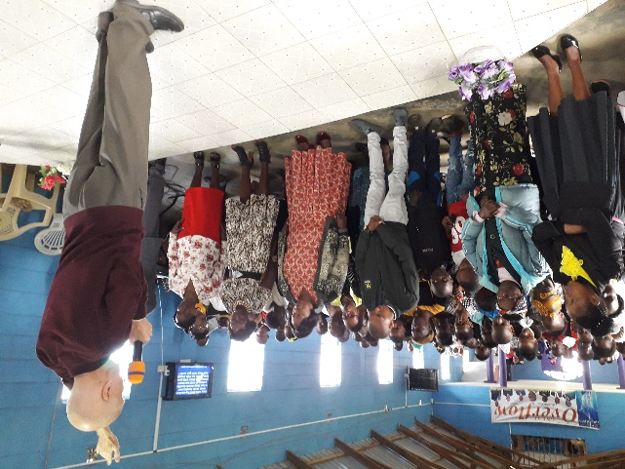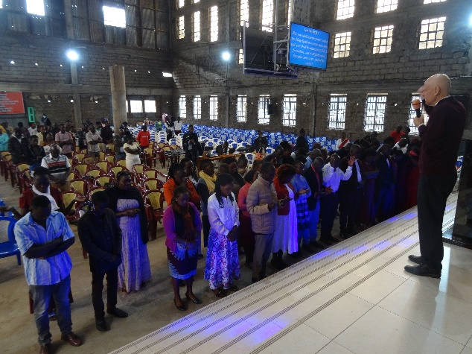

• Many thanks to everyone who has prayed and for the financial support.
• We were able to give gifts to some full-time pastors and distribute baby clothes.

Eltjo en Loes

In connection with the new Privacy Act (AVG) you can let us know when you no longer wish to receive the newsletter.
Send us an e-mail to eprins.1731@telfort.nl and we will ensure that you are removed from our address file.

Colophon: Stichting Prins Worldwide Ministries, Skagerrak 59, 9642 CV Veendam
Telephone: + 31 (0)0598-786261
E-mail: eprins.1731@telfort.nl
Registration no. at the Chamber of Commerce NL- Veendam: 41015464
IBAN: NL17 INGB 0004 5827 70

Board members: K. Heslinga, Veendam; S.L. Prins-Betzema, Veendam; I. Germs-Kaspers,
Veendam; T. van Oeveren, Stadskanaal; A.G. van Oeveren-Lassche, Stadskanaal
ANBI-recognized

